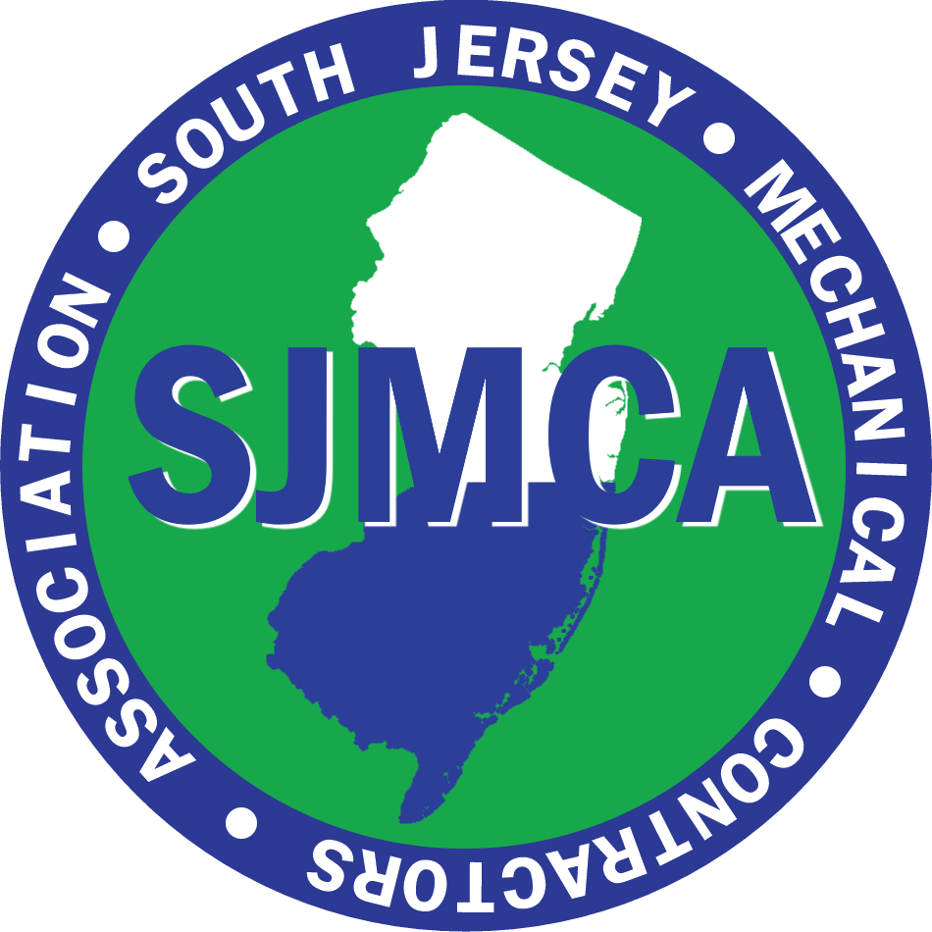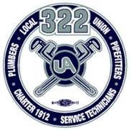
IT’S THAT TIME AGAIN

PLUMBING RELICENSING CLASS

Sponsored by SJMCA and UA LOCAL 322
Saturday, March 22, 2025

Continuing Education
Master Plumber Plumbing Re-Licensing & HVAC-R Class

UA Local 322 Training Center
534 S Route 73 Hammonton NJ 08037
7:30am – 2:00pm
including HVAC 1-2pm
Breakfast and Lunch provided

🛠🛠🛠 🛠🛠🛠🛠🛠🛠🛠🛠🛠🛠🛠🛠 🛠🛠🛠🛠🛠🛠🛠🛠🛠🛠🛠🛠🛠

All NJ Licensed Master Plumbers Are Required to Attend One
Continuing Education Seminar in Order to Renew Their
NJ Master Plumbers License
For The Period of July 1, 2025– June 30,2027
🛠🛠🛠 🛠🛠🛠🛠🛠🛠🛠🛠🛠🛠🛠🛠 🛠🛠🛠🛠🛠🛠🛠🛠🛠🛠🛠🛠🛠

Instructors: John “Nick” Bidinger, Donald Jones, Rich Foltz, and Gary McCloskey

Attendance Requirements: Current Plumbing License
Two (2) pieces of ID (one picture)
Latest National Standard Code Book (2021 National Standard Plumbing Code Manual (NJ Edition) - This is same edition that was used in 2023 training
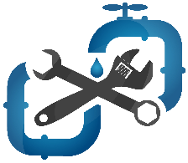
Included in SJMCA Membership

- 2 Attendees per company at “no cost”; $75 each additional attendee

Please indicate # of 2021 National Standard Plumbing Code Manuals (NJ Edition) you require _______ @ $118.00 SJMCA price

Company: ____________________________________________________________________________

Attendees: _________________________________ ____________________________________
_________________________________ _____________________________________
_________________________________ _____________________________________
Please respond via email – cathy@sjmca.org

